Table of Contents
Page Layout
Text
Styles
Tables
Interactive
Miscellaneous

Page Layout

- Master pages include common graphics and text for every page of your document
  - Use the master options to change master page properties, like master title
  - Can have multiple master pages
  - Open the Pages panel and double-click on Master page
    - 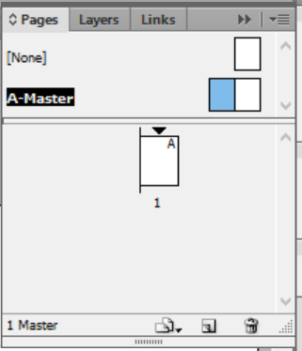
    - The page you have selected appears in the bottom left corner of the window
  - To create a new master page, open the Pages panel
    - Click on Menu > New Master
      - At this point, you can choose to make a master page from scratch or to base it on another master page
    - 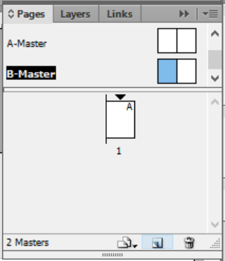
  - To apply a Master to a page, click and drag the master onto the page to which it should be applied
  - Setting up a Master with a primary text frame is good for long, simply designed documents like books
    - When content is added, InDesign will automatically create new pages based off this primary page
- All of the settings for your final document should be in place prior to building the document
  - The one flexible setting is the number of pages
  - Prepare a few styles in advance of importing text
  - Adjusting the layout of your document: Objects will not automatically reflow after you change the layout, so it is important to initially set up your document how you’d like the final document to look
    - Changing document or page settings will not reflow your document
- You can save new document settings as a preset
  - There is a save button next to the document preset [custom]
- Use Paragraph Layout to set text or objects to span columns
  - 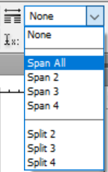
- As you create objects, they stack from bottom to top
  - This is similar to how objects stack in PowerPoint
  - A screen reader will also interpret the reading order from bottom to top
  - To change object order, click on Object and select Arrange
    - Expanding layers will allow you to see all objects in a page
    - 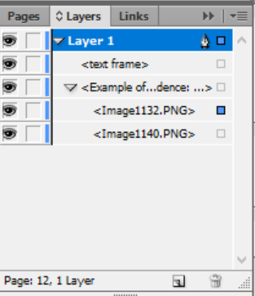
- To wrap text around an object, click Window and select Text Wrap
  - Select the object around which the text will wrap and click Wrap Around Bounding Box
    - You can also change the offset (space around the object)
    - 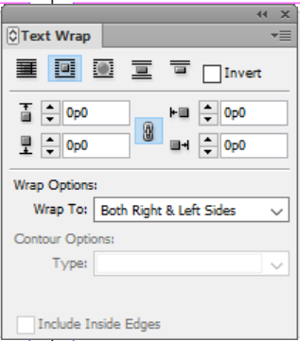
      - For irregular shapes: Select object
      - In Window, choose Text wrap > Wrap around shape
      - 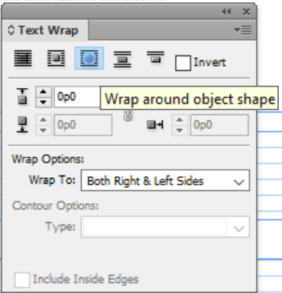
    - You can manually change the wrap options
- To break the document into different sections:
  - Open the Pages panel and right click on the page that starts the new section
    - 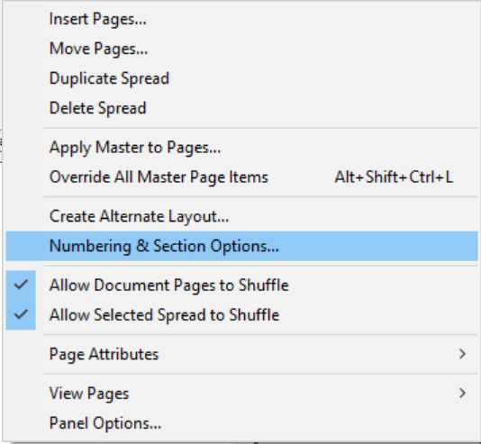
  - Click on Numbering and Section Options > Start from page… or Continue from previous…
    - 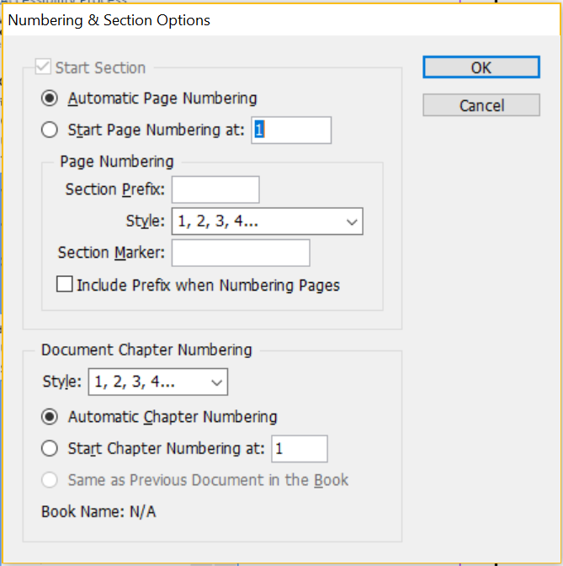
  - To view a page, open the Pages panel and click the down arrow over the page thumbnail
    - Example of different sections: numbering an introduction as i-xii
- To insert a break character: Select the Type tool > Insert Break Character
  - This is similar to a page or column break in Microsoft Word
  - 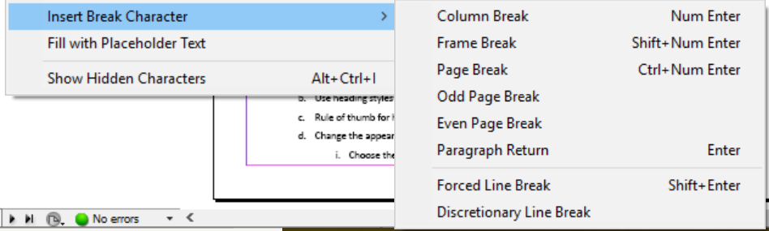
- To create a soft return (similar to a line break in Microsoft Word): Use Forced Line Break

Text

- Thread text: If text is overflowing a frame, click the red + symbol
  - 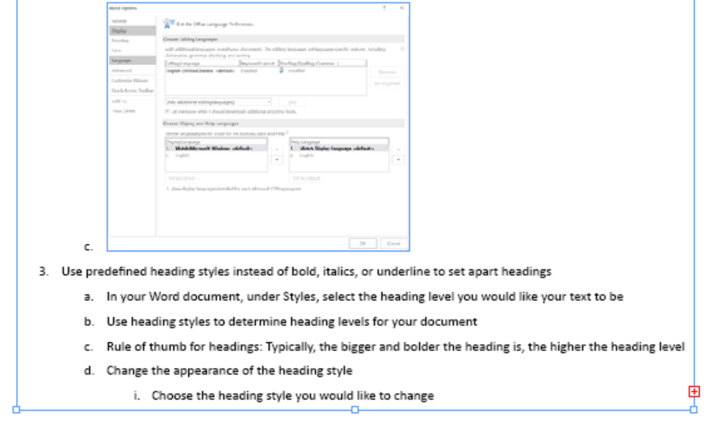
  - This loads text into the cursor, so you can put the overflow text into another frame
    - Text threads are blue lines that show connected frames
    - A small blue arrow in the In Port frame shows the continuation of threaded frames
      - 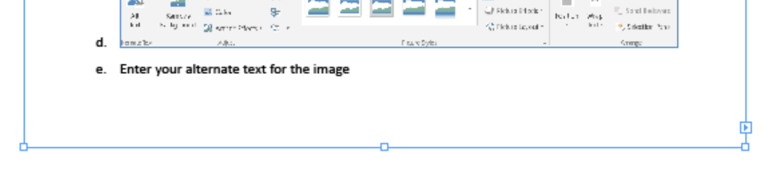
    - Empty or hollow In Port boxes show the start of the story
      - 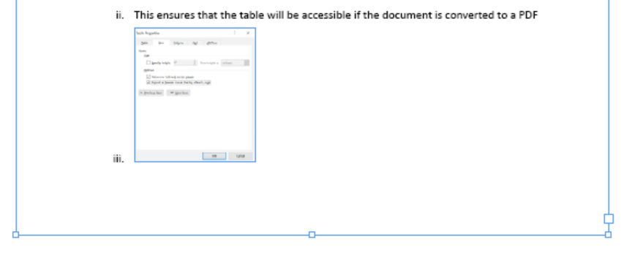
    - Select View > Extras > Show/Hide Story Threads
    - Threading helps reading order to be correct when exporting to PDF
    - 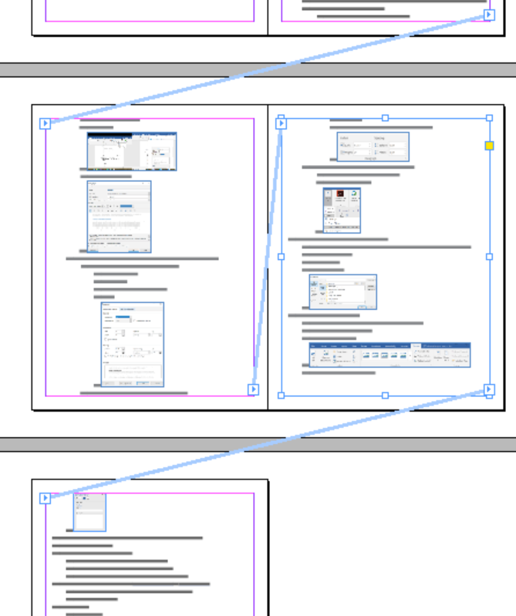
  - Click and drag to create a text box for the threaded text
    - This is useful for stories, where you may want to continue on a later page
- Jump lines like “continued on page…” and “continued from page…”
  - To add these lines, create a new text frame and move it completely within the story frame
    - Type in the text of choice
    - Select Type > Insert Special Characters > Markers > Next Page Number (or Previous Page Number)
  - Then turn on text wrap in the story frame
  - To see where to set the “continued from page…” line, follow the text threads
  - 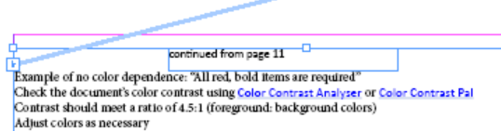
- Use the Articles panel: Window > Articles
  - This takes all the pieces of a story and puts one section tag (<Sect>) around them
  - It also defines the reading order
  - Meant for one threaded story or one complex page: Does not work well when rolls over into the second page
  - Click on one piece of the article (Example: the article’s title) and drag into the Articles window
    - This will show a dialog box to create new article
    - Check off “include when exporting to PDF”
    - 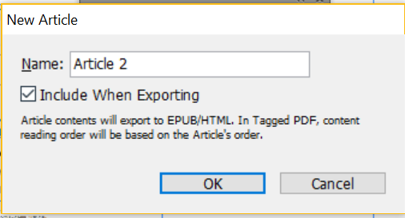
  - Drag all pieces of the article into the Article window
    - 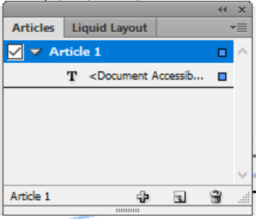
- To add page numbers: Draw a text box
  - Then select Type and click on Insert Special Character
  - Select Marker
  - 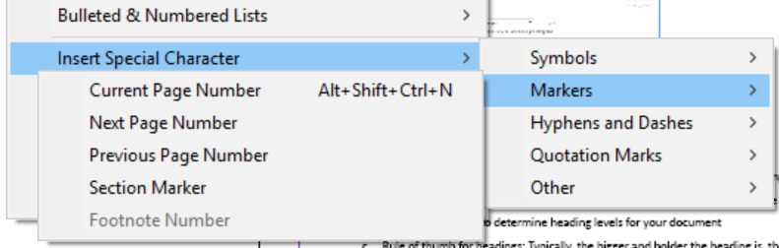
- Use autocorrect for misspellings: Select Edit and click on Preferences > General > Autocorrect
  - Add in your common misspellings
  - Many common errors are preloaded
  - Can set it up to replace abbreviations or acronyms with full text
  - 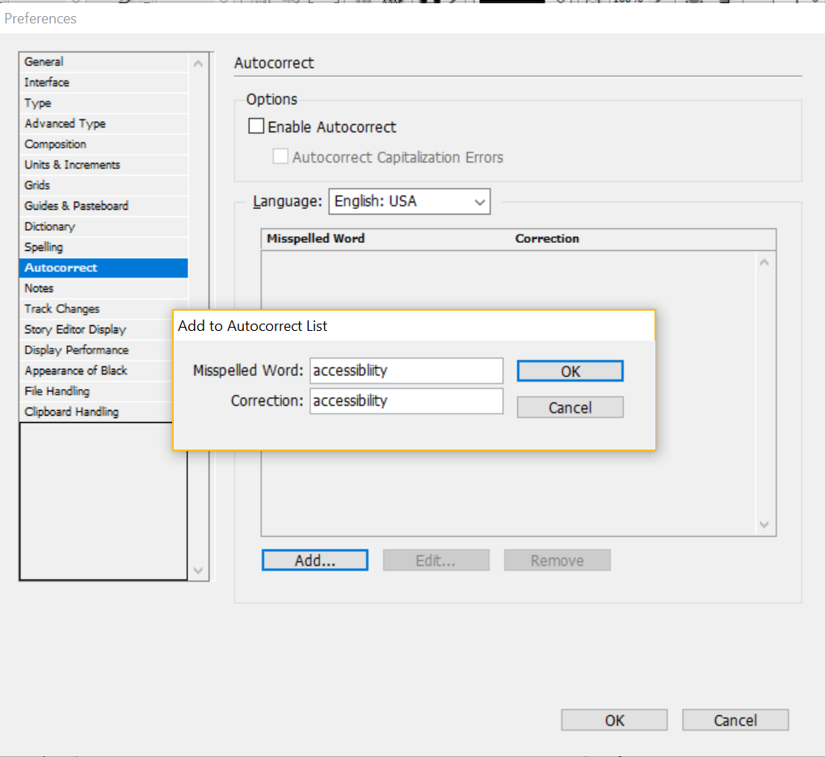

Styles

- Use styles to keep formatting consistent
  - Click on Window and select Styles > Paragraph Styles (or any other style you would like to set)
    - Alt + New Style opens a dialog box for the new paragraph style
    - 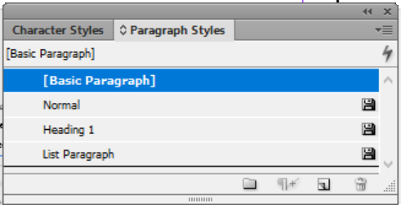
  - Changing a style updates any text where the style is used
  - Use character styles to change the look and feel of a character
    - Example: Making text bold or italicized, changing color
    - 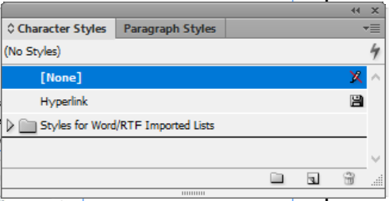
  - Object styles are very similar to paragraph and character styles
    - Select Window > Styles > Object
    - Be sure to check off Apply Style to Selection
    - 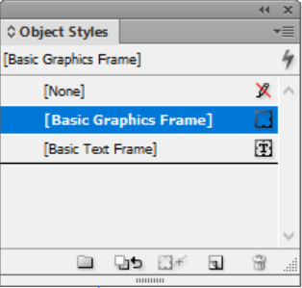
- Click on each element to see what style is assigned to the text in Paragraph styles
- To ensure that a style exports with the correct tag, right click on the style
  - Select Edit (style name) > Export tagging
  - Set the appropriate tag in the drop down
  - The only automatic tagging you should use is for lists
  - 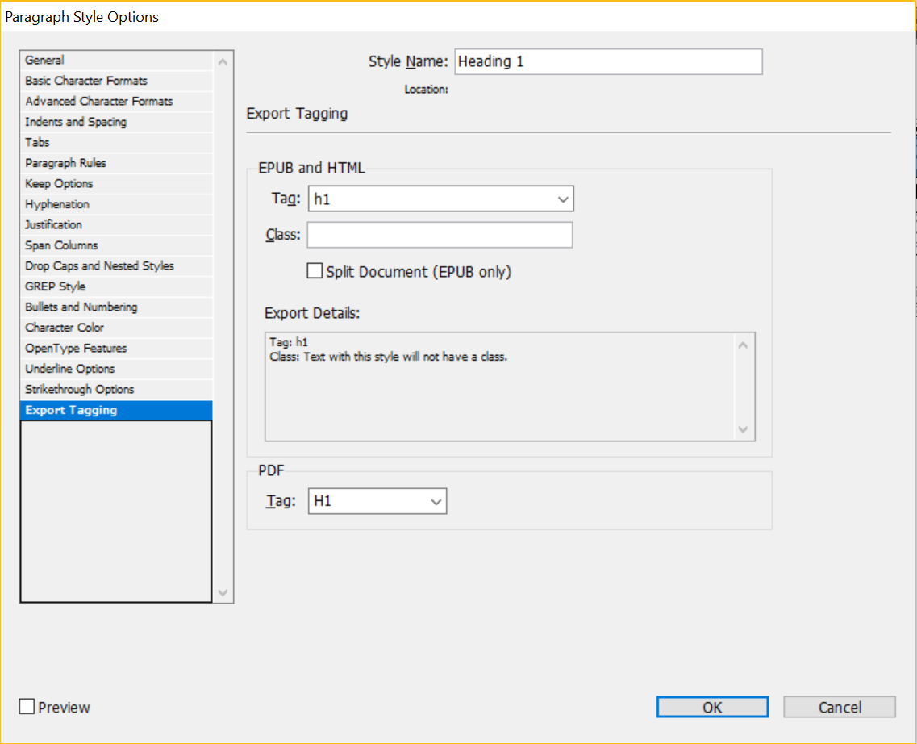
- To bring text into the document: Click on File > Place
  - Preserve styles and select Show import options
    - 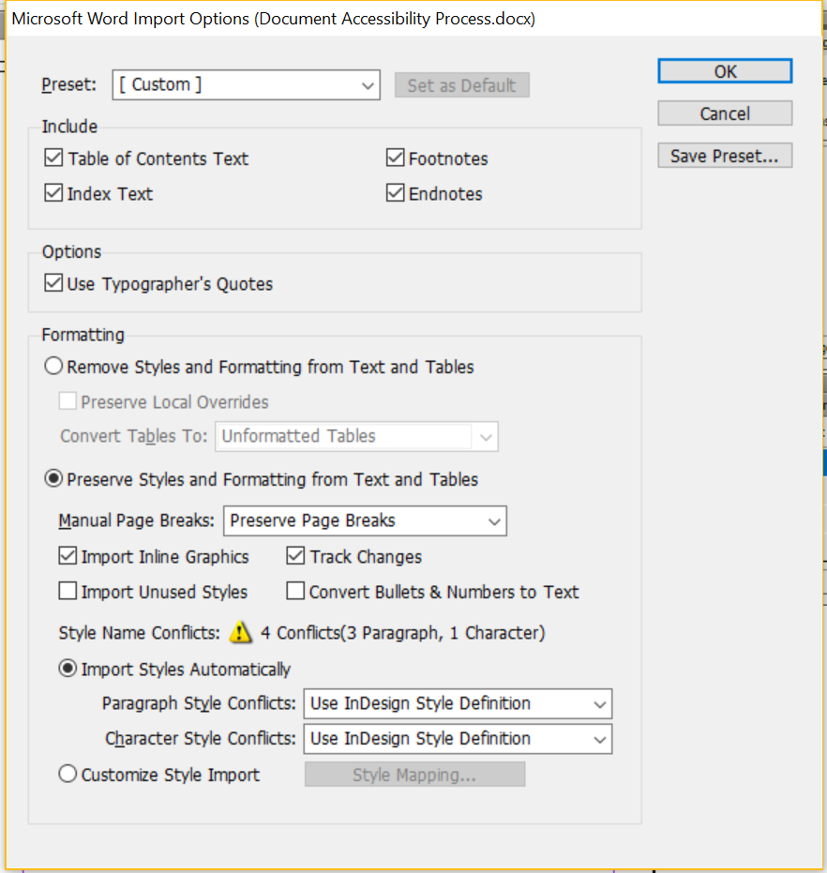
  - Select Customize style import > Style mapping: This allows you to assign Microsoft Word styles to specific InDesign styles
    - Can also be used with your custom InDesign template
    - 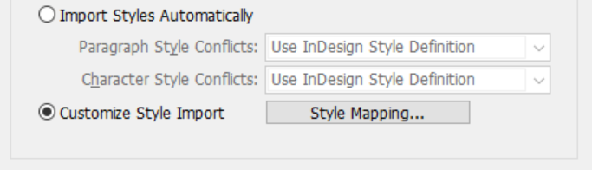
  - If choose [new paragraph style], not much of the styling is in your control: InDesign will just import all Word styles as best as it can
    - Note: You do not have much control over properties in brackets []
    - 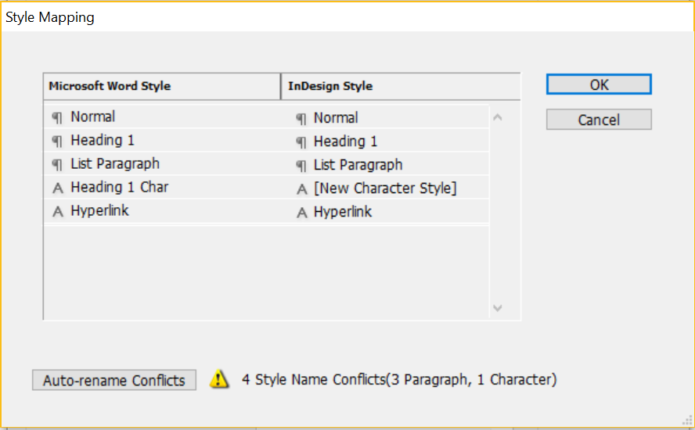
  - The bottom options allow you to define your style
    - Only need to customize headings and other text formats when you know you’ve used it in the Word document
    - All other styles can be mapped to [new paragraph style]
  - Must always define list styles (bullets and numbering)
    - Otherwise, tags will not be correct when exported to PDF
  - The only time you can do style mapping is prior to placing text
    - Otherwise, have to start over or manually fix
- Right click on a style to change it and select Redefine Style
  - This applies to paragraph and character styles
  - Apply changes to text and select Redefine style using updated text
  - Check Redefine Style when changing all fonts: This will change the style and all text that uses the updated font
    - Find all text using a style with the Find and Change dialog box: Select Edit > Find/Change
      - Can use this to find and replace formats
      - This relies on defining styles ahead of time
    - 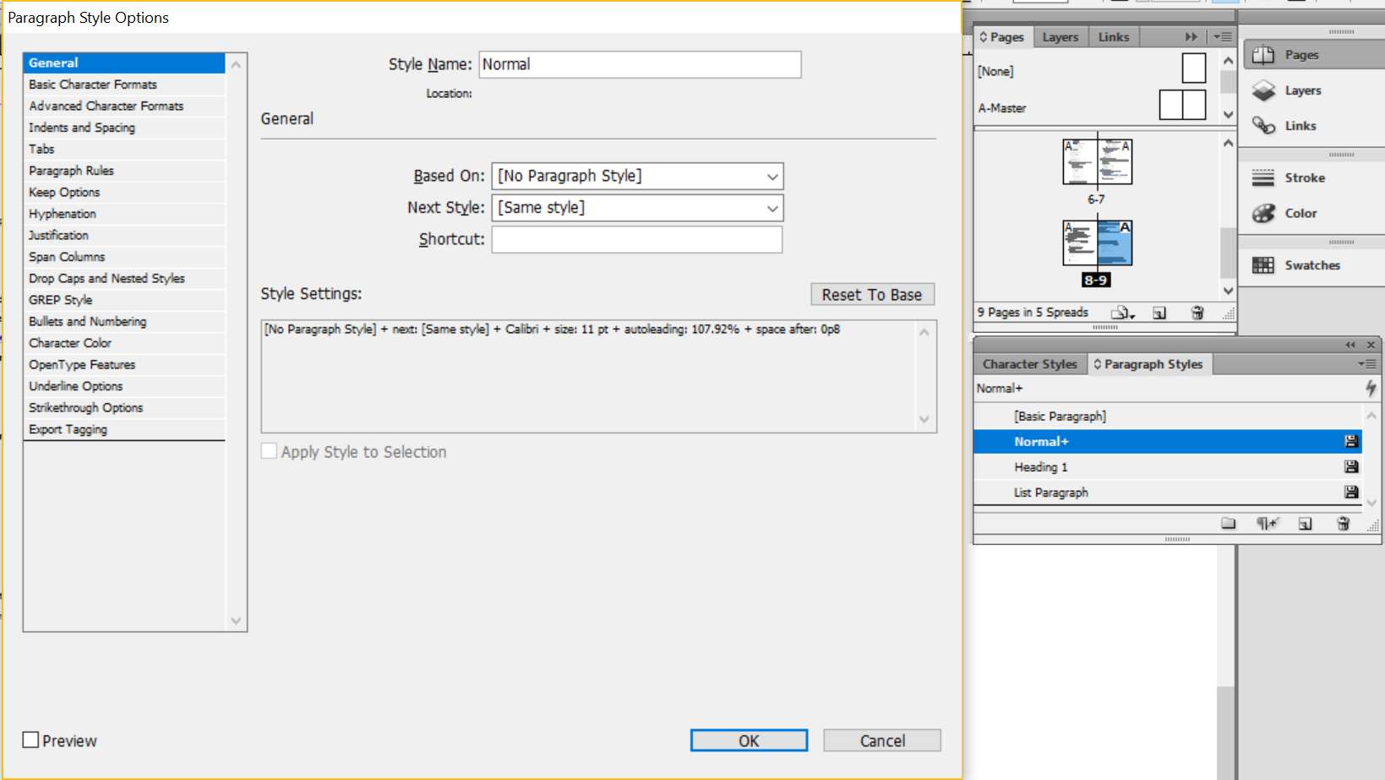
- Load styles from other documents by opening the Paragraph styles panel
  - Click on the hamburger menu and select Load Paragraph Styles
  - 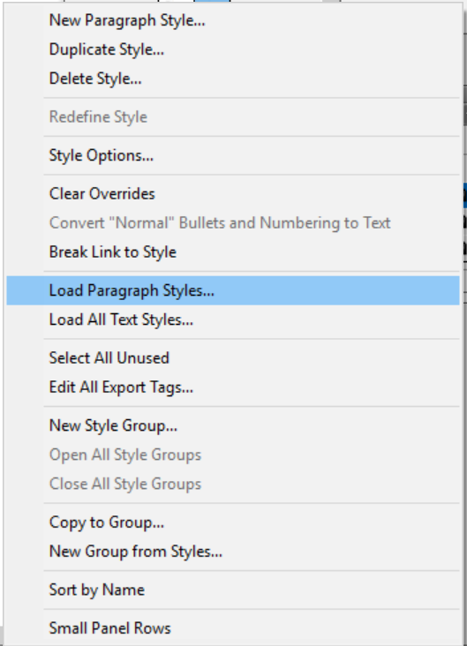
  - InDesign will ask where the styles are located: Choose the document from which you want the styles and select the styles you want
- Bullets and numbering: Open the paragraph control panel by double clicking on text and switching to the Paragraph panel
  - 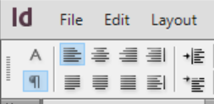
  - Click on bullets/numbering
    - 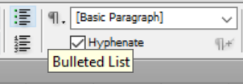
  - Change the style using the Paragraph panel menu and selecting bullets and numbering
    - Allows you to change the numbering style, how much space is between the bullet or number and the text, the bullet or number’s color, etc.
    - 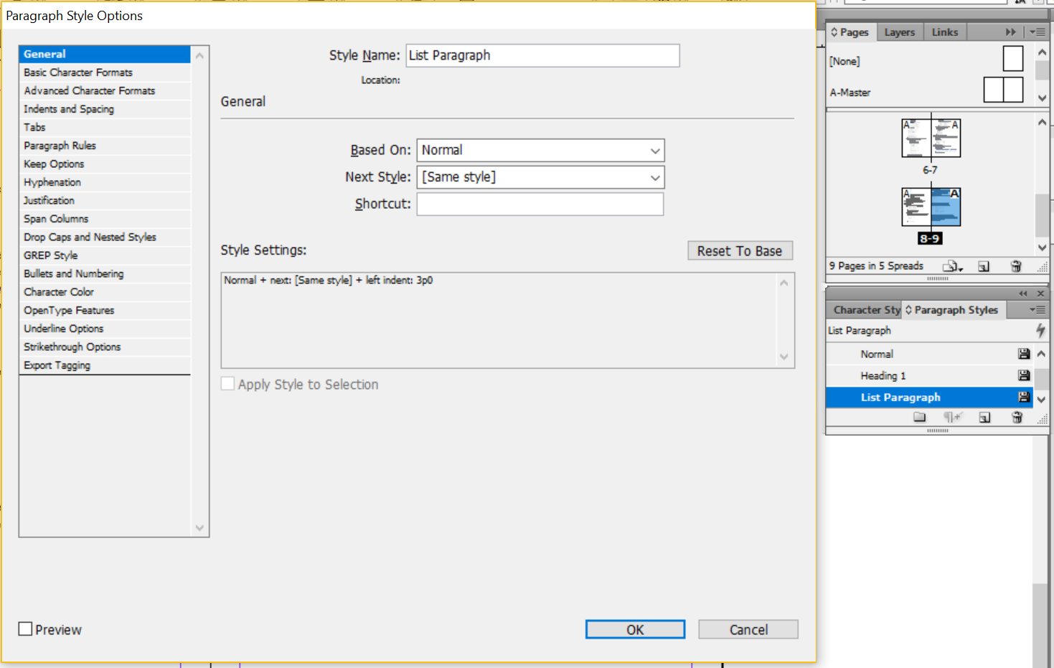
  - Only use Unicode characters for bullets, not WingDings or similar characters
- Nested Styles: Double click on a Paragraph style and select Drop caps and nested styles in the dialog box
  - 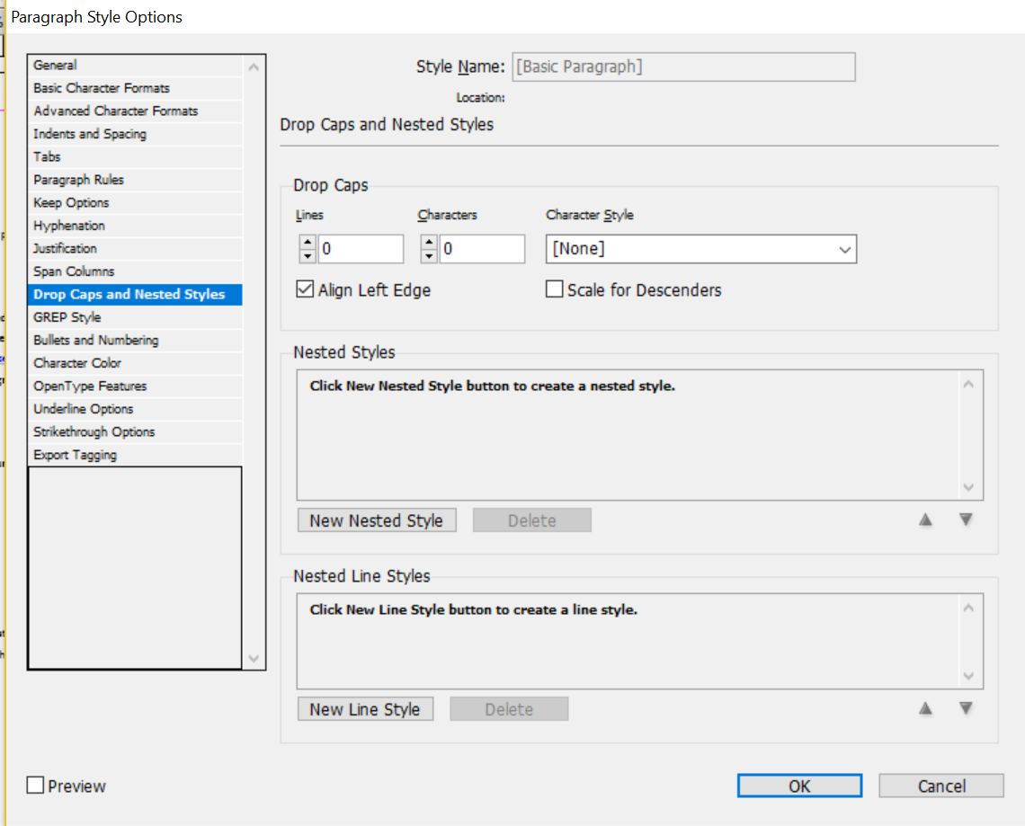
  - Nested Styles are similar to CSS in that there are parent and child styles
- Do not use skew to create false italics: This does not change the code to show emphasis

Tables

- To draw tables, use the Type tool to draw a box
  - Table tool can be used after drawing the frame
  - Click Table > Insert Table to set up your table
  - Use Table > Table Options > Table Setup to set header and footer rows
    - 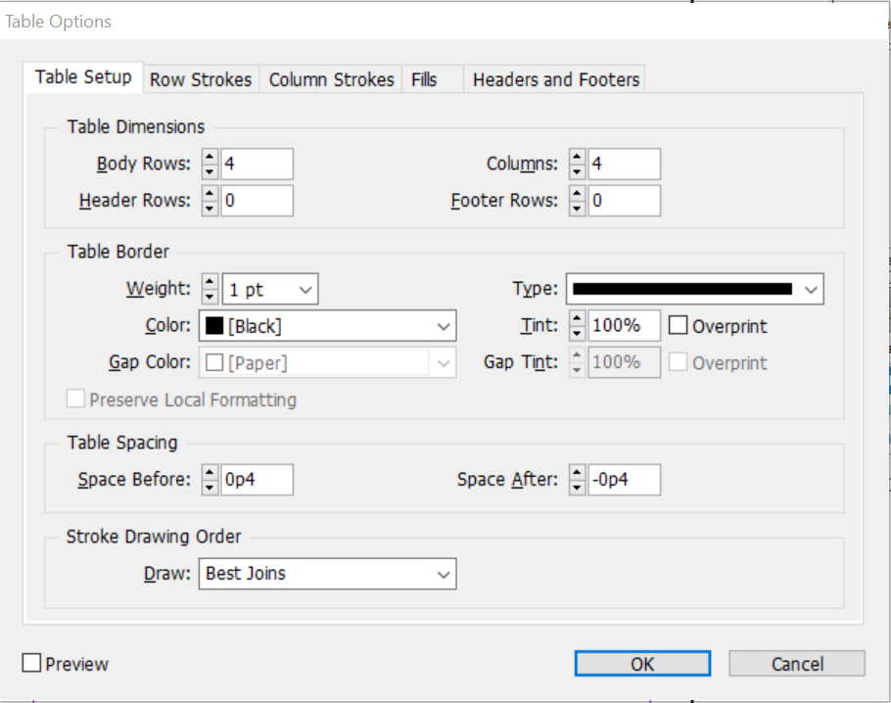
  - Use tab to add rows
- To set table headers and footers from existing rows:
  - Select a row
  - Click Table and choose Convert Rows
  - 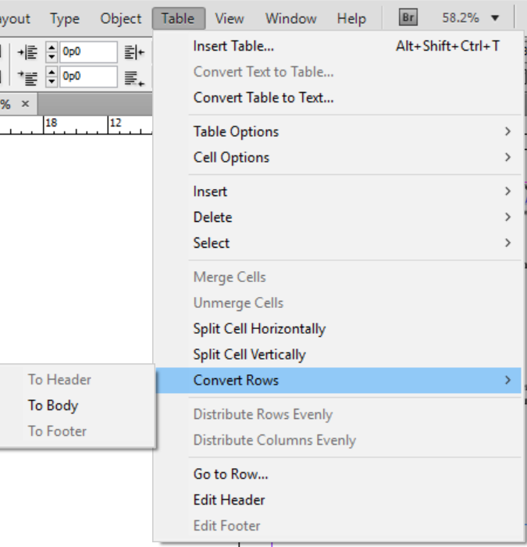
- You can embed styles into table styles
  - 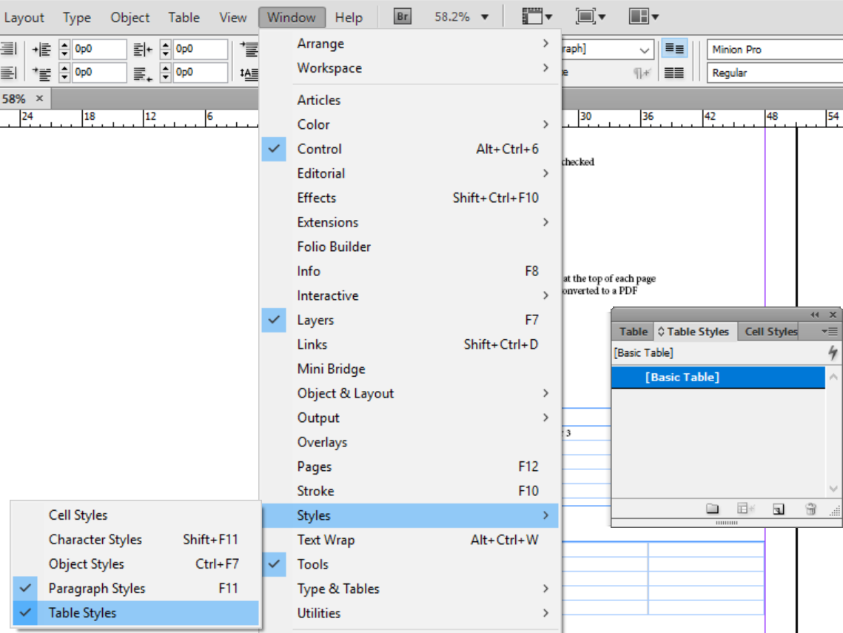
  - Select Window > Styles > Table styles to edit table style
- Convert table to text: Select Table > Convert table to text
  - Set options like column and row separators
  - Text is separated by tabs, which shows InDesign how to create columns
    - New paragraphs show where rows should be

Interactive

- Table of Contents: InDesign knows the Table of Contents based on headings defined in Paragraph styles
  - Select Layout and click Table of Contents
  - 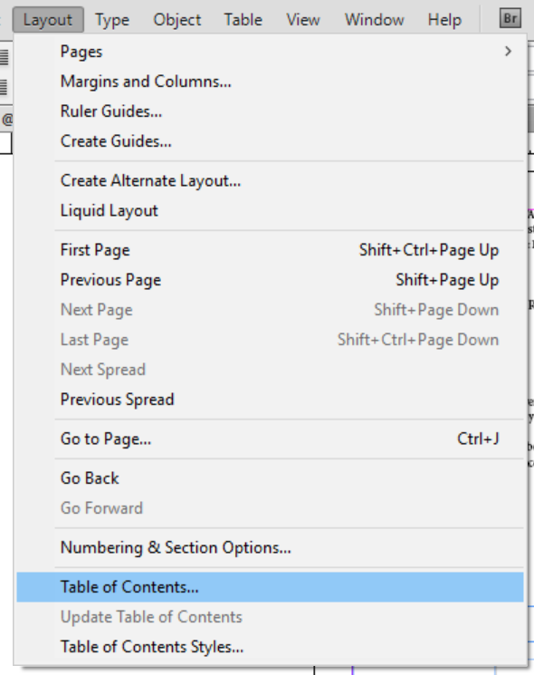
  - Include paragraph styles
    - Example: Heading 1
    - Table of Contents styles are automatically created when you generate your Table of Contents
    - 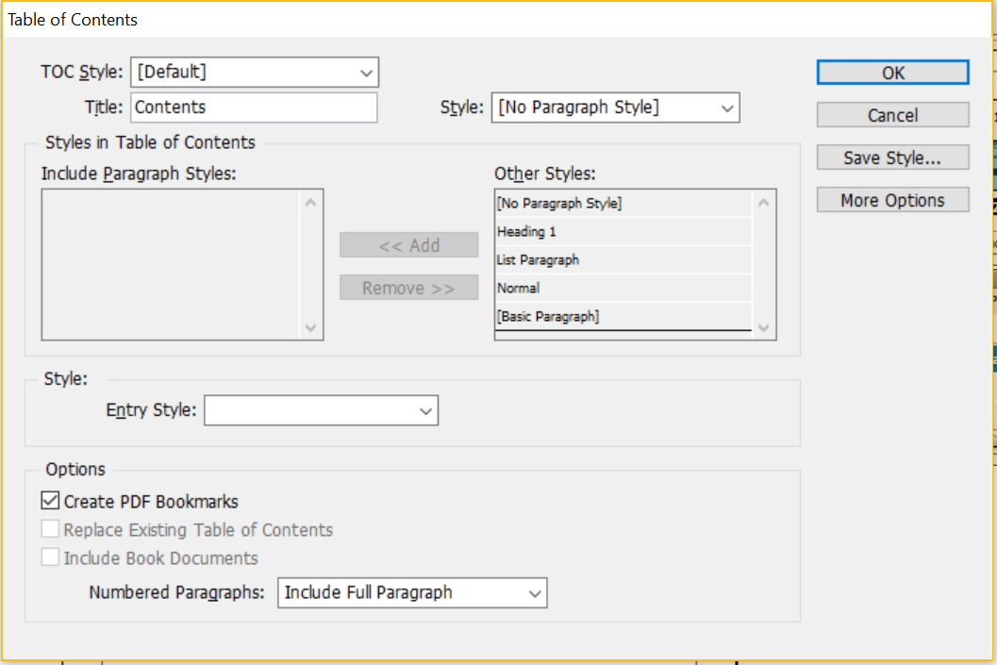
  - You can automatically create bookmarks in your PDF from the Table of Contents
  - You can also automatically create text anchors in the source paragraph, which allows you to click and jump directly to that point
  - Include all book documents in your Table of Contents
  - Manually set page number styles for any paragraph styles included in the Table of Contents
- To create bookmarks: Select Window > Interactive > Bookmarks
  - Select the text you would like to be your bookmark and click Create new bookmark
  - 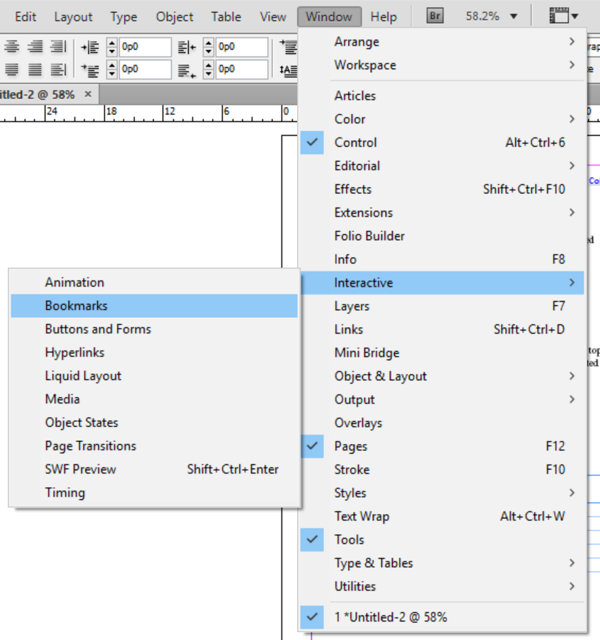
  - When exporting to PDF, click Include bookmarks
  - Add bookmarks to any document where you want users to know information, especially if that information is not on the first page
- To add hyperlinks, select Window > Interactive > Hyperlinks
  - 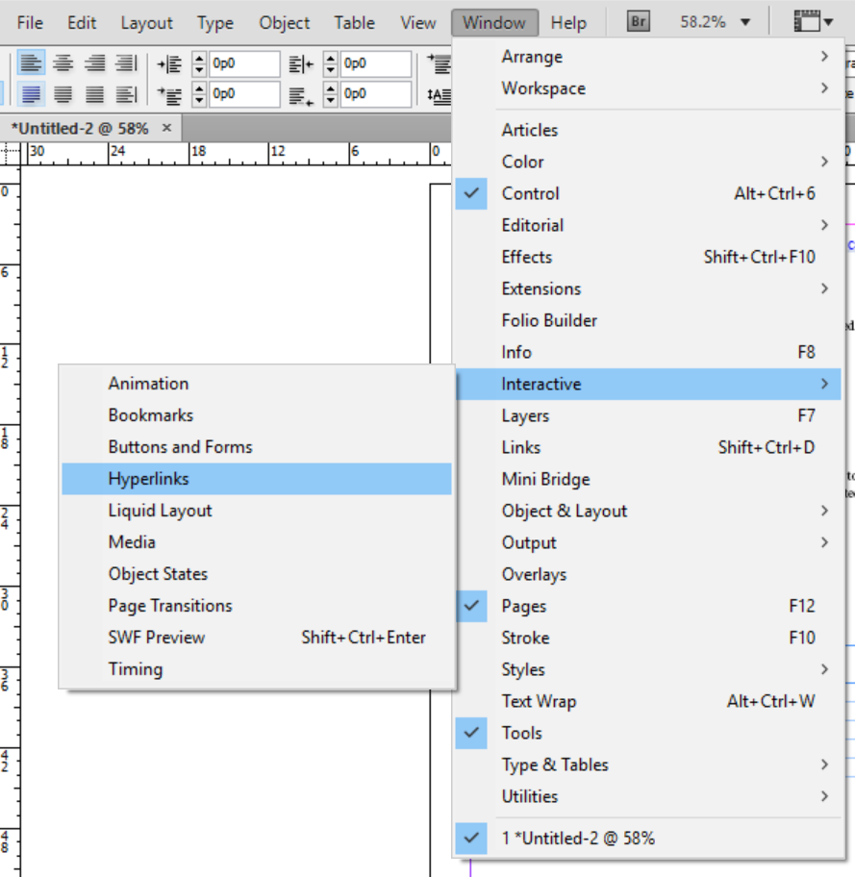
  - Select the text you would like to be your hyperlink and type in the URL
  - Can also set links to send to file, email, etc.: Create a new hyperlink from the hamburger menu
  - InDesign automatically creates a character style called Hyperlink, which you can edit

Miscellaneous
- To create an accessible PDF: Select Paragraph styles and select Style options
  - Select Export Tagging
  - Select the appropriate PDF tag
  - 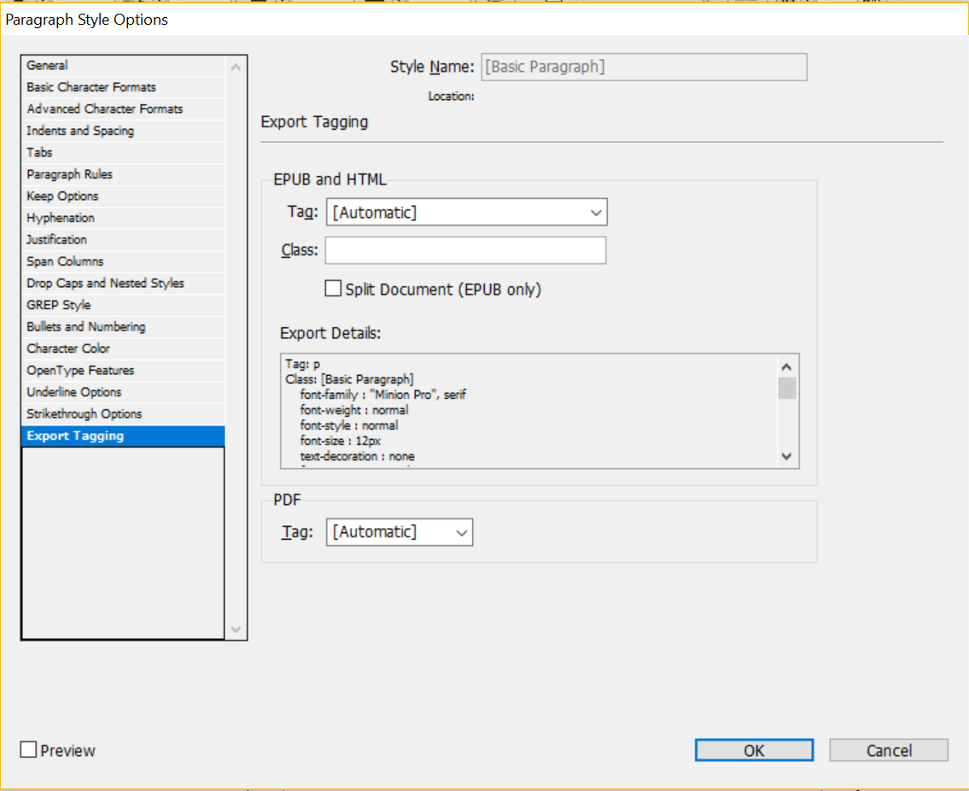
  - Do a 1:1 match: Leave lists, footnotes, and endnotes as is, but check the mapping of other styles
  - Always save before sending to PDF
  - Choose File > Export >Save as type > PDF Interactive
    - In the export dialog box, export as pages (not spreads)
    - Check the boxes for Create tagged PDF and Use structure for tab order
    - 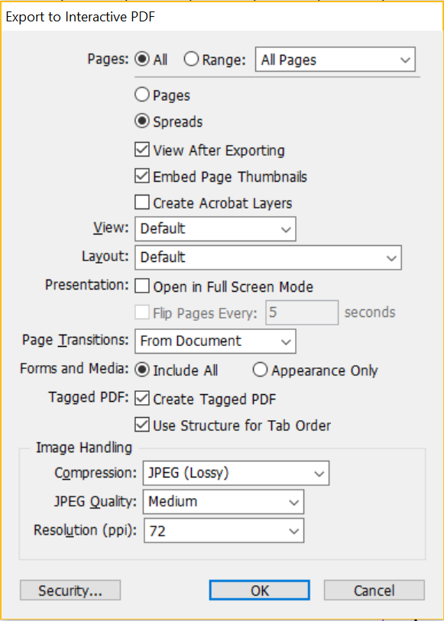
- Under Security, enable text access of screen reader by checking the box
  - 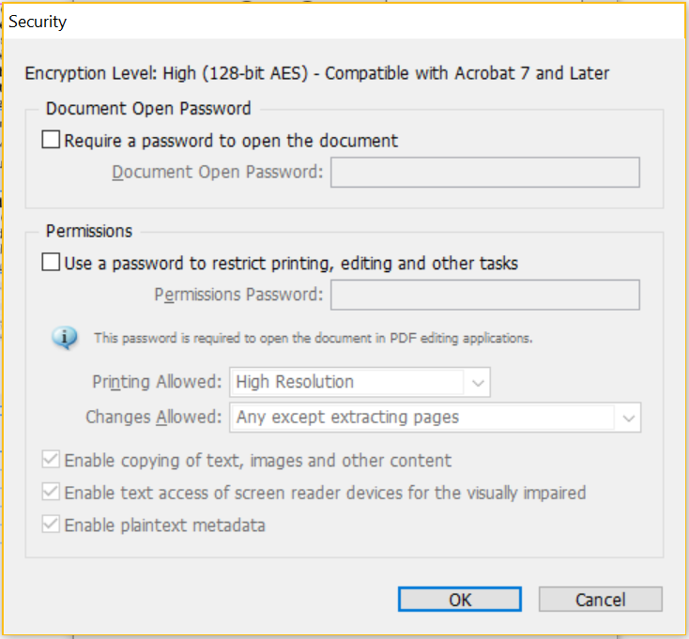
- To add alternate text to images:
  - Select Graphic and then click Object
  - Under Object, select Object export options
  - In Object export options, select Alternate text source > Custom
  - Input your text
  - 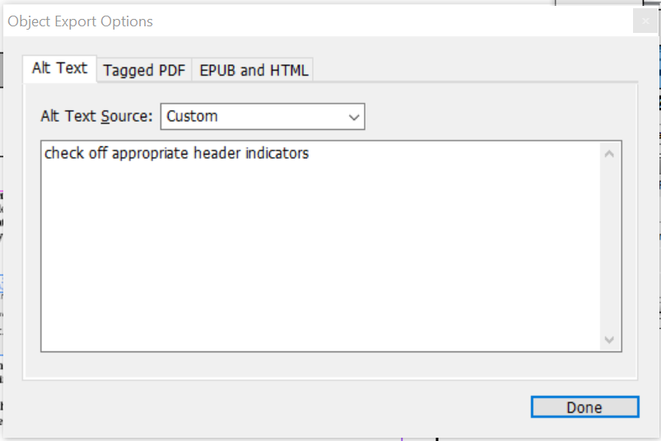
- Add metadata captions:
  - Select Object > Captions > Caption setup
  - 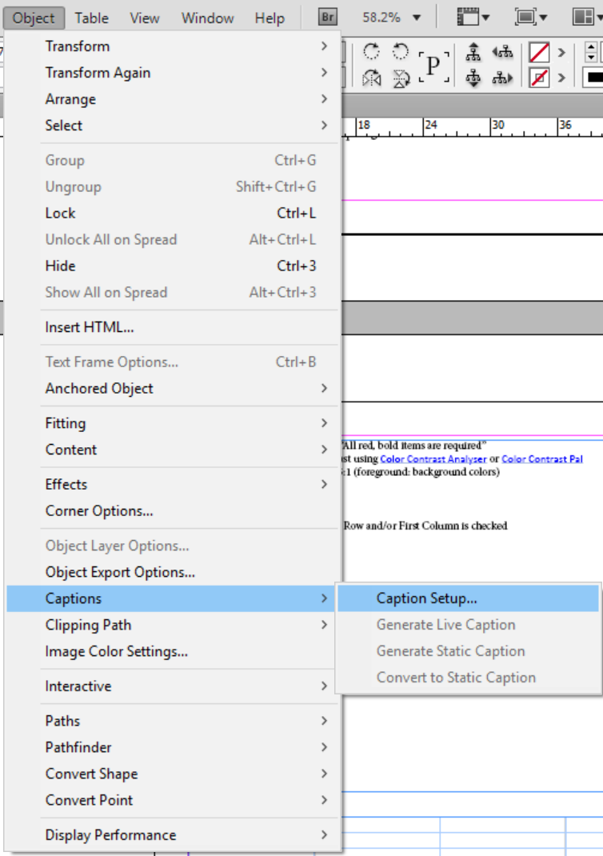
  - Change metadata type to Description
  - Group captions with image
  - Fill out the description field for each image and enter descriptive text
    - This will be used as captions
  - 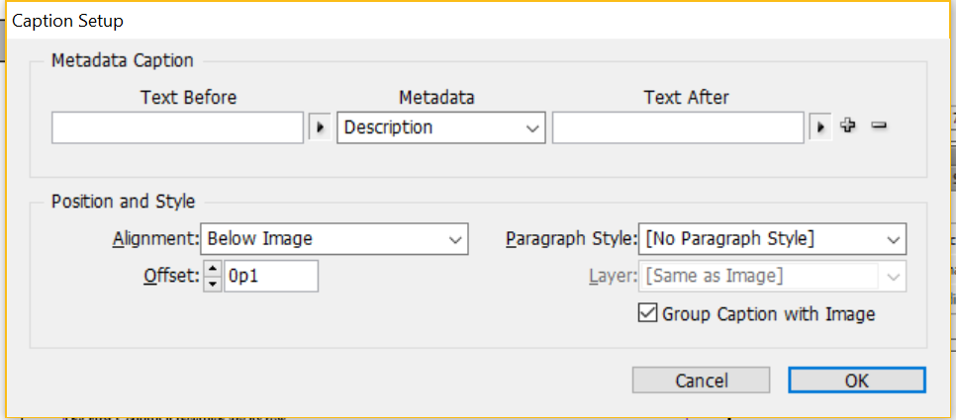
- Add swatches and styles to your Creative Cloud library: Window > CC Library
  - Click on the swatch or characters with styles and add to library
  - Can add graphics to library as well
  - Easy to use between documents
  - Can share the library with other documents and users
- To save InDesign templates, click File
  - Select Save As and save the file as a .indt file
  - 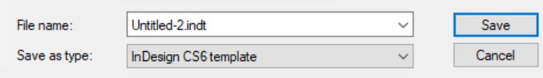
  - When opening the template, can open as a new blank document (normal), the original template, or a copy of the template
    - The default open is as a new blank document
- Stick to a single layer using the Layers panel: Window > Layers
  - 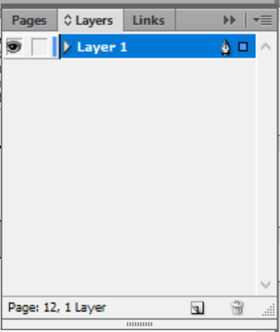
  - Adding additional layers changes the reading order dramatically
  - Click and drag objects in the Layers window to reorder: This affects the PDF’s reading order
    - Check off Use for reading order in tagged PDF
  - If you must use multiple layers, flatten before exporting to PDF
    - You will have to manually check the reading order, because it will be changed in the PDF

