Document Accessibility Process
Use the Check Accessibility tool to determine accessibility issues with your document and follow the prompts to fix issues. The Check Accessibility tool is located under File > Info > Check for Issues in Microsoft Word 2016 and under Review in Office 365.

If not using the Check Accessibility Tool, use the following steps:
- Under File, select Properties
  - Click Advanced Properties
  - Under Summary, add a Title property
  - The Title must be descriptive of the document’s content; it may be the same as the filename
  - 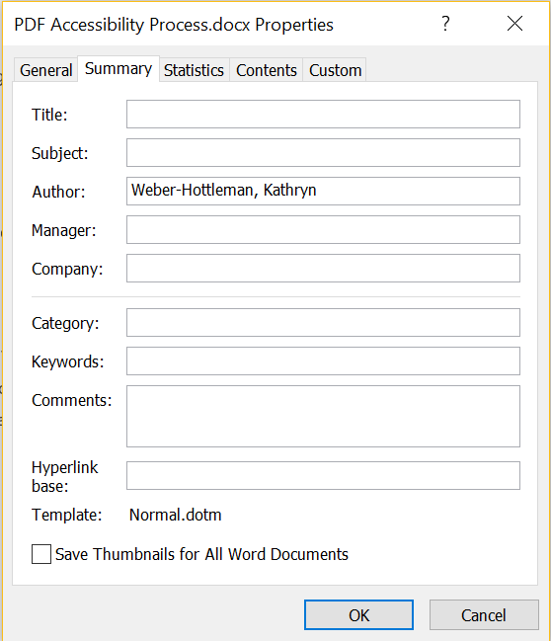
- If your document is in a language other than English, select Review
  - Under Language, choose Language Preferences
  - Set the editing language and, if necessary, the display and help languages
  - 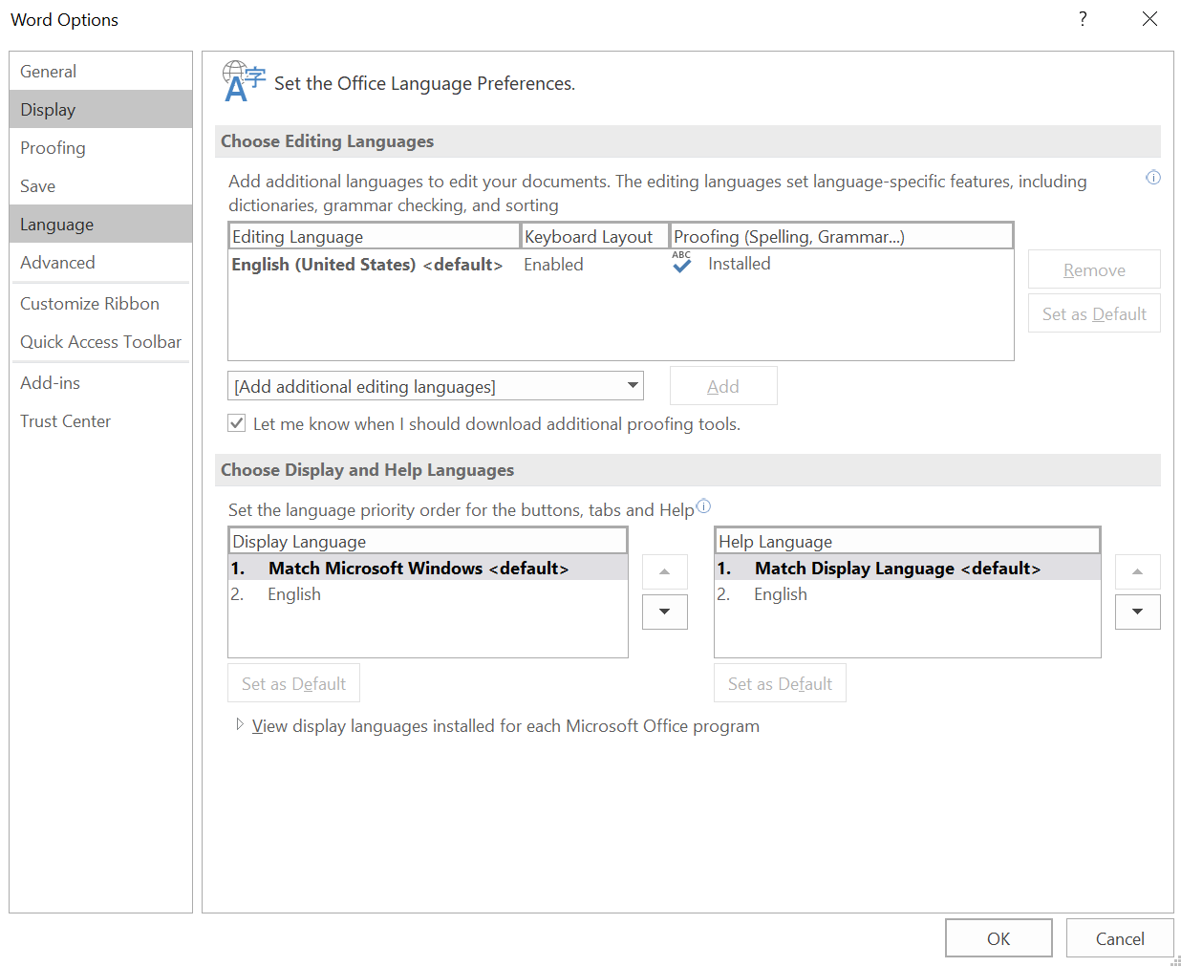
- Use predefined heading styles instead of bold, italics, or underline to set apart headings
  - In your Word document, under Styles, select the heading level you would like your text to be
  - Use heading styles to determine heading levels for your document
  - Rule of thumb for headings: Typically, the bigger and bolder the heading is, the higher the heading level
  - Change the appearance of the heading style
    - Choose the heading style you would like to change
    - Right click on the heading style
    - Click on modify
    - Change the style and save
    - 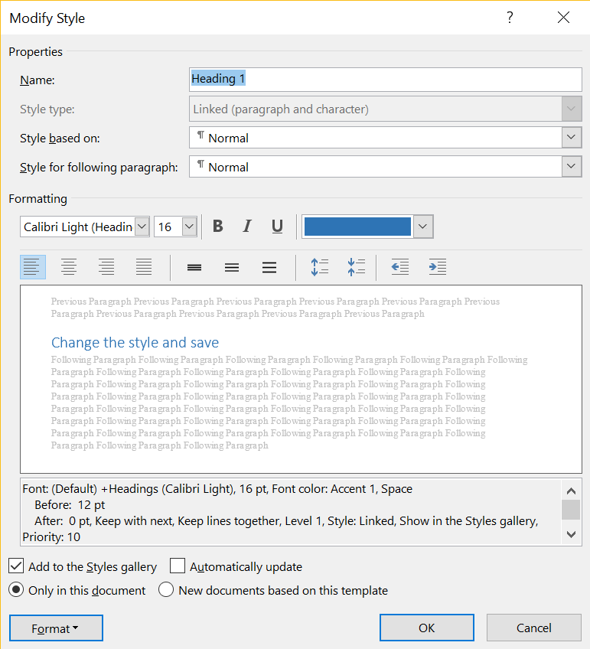
- Set links in text as hyperlinks with meaningful link text
  - Select text to be hyperlinked: Avoid “click here” and instead have text describe the link’s target
  - Under Insert, select Links
  - Click on Hyperlink
  - Add the desired URL
  - 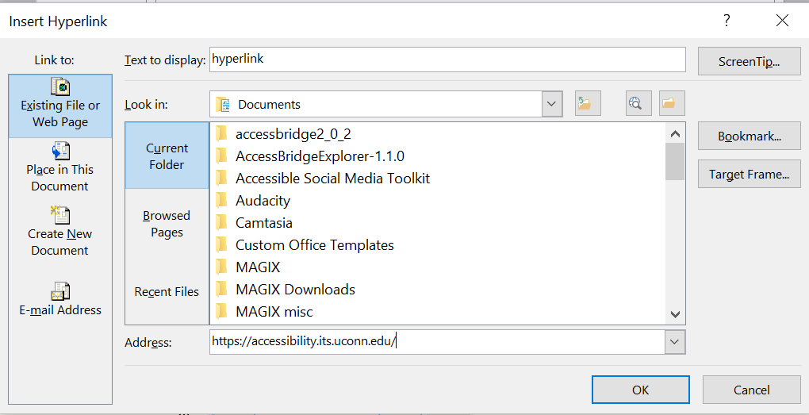
- Set ALTs (alternate text) for all images
  - Click on any image in your document
  - Under Format, click Alt Text
  - 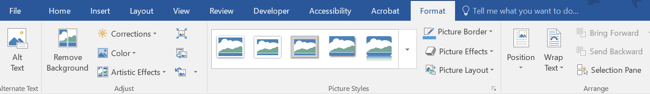
  - Enter your alternate text for the image
  - 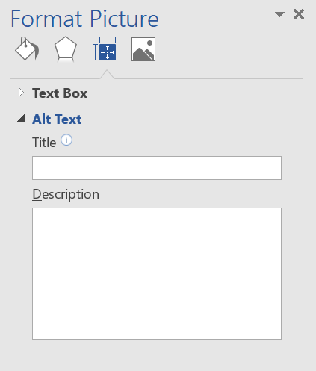
- Include transcripts or textual descriptions for all purely audio or purely visual media
- Use only captioned multimedia
- Check the document for color dependence
  - Ask if the document uses color only to convey meaning
  - Example of color dependence: "All red items are required"
  - Example of no color dependence: "All red, bold items are required"
- Check the document's color contrast using Color Contrast Analyser or Color Contrast Pal
  - Contrast should meet a ratio of 4.5:1 (foreground: background colors)
  - Adjust colors as necessary
- Set table headers
  - Click on the table
  - Under Design, ensure that Header Row and/or First Column is checked
    - 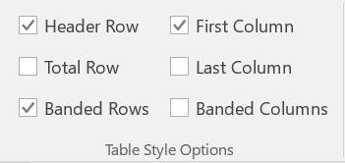
    - Use Header Row if headings are over columns
    - Use First Column if headings are by row
  - Right click on the table
    - Under Table Properties, check the box for Repeat as header row at the top of each page
    - This ensures that the table will be accessible if the document is converted to a PDF
    - 